 | 
Prices include labour, water resistance testing (if applicable), bracelet and case refinishing. Replacement parts are not included in the price. Estimate will be faxed, phoned or e-mailed to you. There is a two-week turn around if all parts are in stock.
** All overhauls come with a 1-year warranty. **
 | Overhauls for Automatic and (winding)
 | Rolex Automatic | $225.00
 | Oris Automatic | $195.00
 | Omega Automatic | $195.00
 | Tag-Heuer Automatic | $195.00
 | Overhauls for Automatic Certified Chronometers
 | Rolex Automatic | $325.00
 | Oris Automatic | $275.00
 | Omega Automatic | $275.00
 | Tag-Heuer Automatic | $275.00
 | Overhauls for Automatic Chronograph (winding)
 | Rolex Automatic Chronometer | $450.00
 | Oris Automatic Chronometer | $375.00
 | Omega Chronometer | $375.00
 | Tag-Heuer Chronometer | $375.00
 | Overhauls for Electronic Quartz
 | Rolex | $325.00
 | Oris | $175.00
 | Omega | $175.00
 | Tag-Heuer | $175.00
 | Other Watch Repair Services
 | Gold plating case and bracelet (10 microns) | $175.00
 | Case restoration | $150.00+
 | Dial / Face refinishing | $85.00
 | Rolex / Oris / Omega / Tag-Heuer Watch crystals (acrylic) | $70.00
 | Rolex / Oris / Omega / Tag-Heuer Watch crystals (sapphire) | $275.00
 | Water Testing for water-resistant watches (Tag-Heuer Rolex etc.) | $30.00
 | Batteries (Swiss Renata) silver oxide installed (includes Water Test) | $30.00

email: charlie.s@squireswatches.com
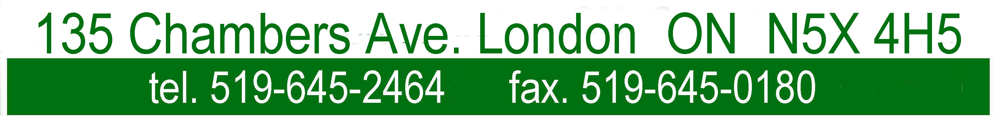
 | prices subject to change without notice

